Name: ___________________________ Military Systems
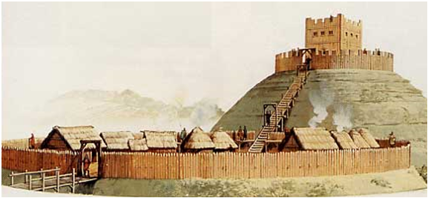
Competition between medieval landowners through the desire for land and the wealth it produced was fierce. Landless knights scoured the lands for opportunities to advance their standing. Whole communities suffered when wars ravaged areas. Fortified structures therefore became a feature of the land. Castles grew out of the Roman idea of a stronghold or ‘castrum’. Castles were built to control road junctions, river crossings, mountain passes ports and important towns or villages.
The first castles appeared in the Loire valley in France during the 10th century. Castle building spread through Europe with stone structures replacing the earlier wooden defences.

The earliest castles were built on a high mound of earth called a ‘motte’: easier to defend from and it provided a clearer view of the surroundings. A tower, or ‘keep’ was built on the ‘motte’, this is where the lord and other nobles lived. Around the motte was the ‘bailey’ where soldiers, horses, the kitchen and stores existed.

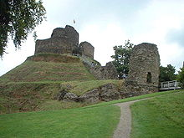
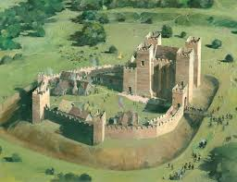

THINK: What similarities in history between these two religions and in this same region can you see?

THINK: List several reasons, for both sides, why these situations occurred.

CONSIDER: What compromises could have taken place that could have avoided these situations from taking place?

